Lab Assignment 4: Interactive Data Visualization

Due: 02:00 PM Feb 11, Wednesday

# Visualization with Tableau Software

Watch the [Getting Started](http://www.tableau.com/learn/tutorials/on-demand/getting-started-8?signin=1622f292de3f17156f52e3cb5665d375) and the [Dashboard Development](http://www.tableau.com/learn/tutorials/on-demand/dashboard-development) online tutorial of Tableau. Download the [Example Car.twb](https://public.tableausoftware.com/profile/cis4340#!/vizhome/ExampleCar_0/Dashboard1)x. Open it in Tableau.

Assignments: Preprocess the auto car data set so that you can successfully load the data into Tableau and answer the following questions.

1. Create the first sheet, plot a time series for all the origins that show how many new cars they introduces during each year. Do you see some interesting trends?
2. Create the second sheet, plot a time series for all the car companies that show how many new cars they introduces during each year. Do you see some interesting trends?
3. Create the third sheet, showing the stacked bar plot of the number of cars with different cylinders produced by each **car company**. Add the ‘Model’ column as a filter to the sheet.
4. Create the forth sheet, plot histograms for each attribute. Pay attention to the appropriate choice of number of bins. Write 2-3 sentences summarizing some interesting aspects of the data by looking at the histograms.
5. Create the fifth sheet, do the same as the ‘Mpg Weight’ sheet in the example work book, but with other two features, add the ‘Origin’ column as the Color Legend.
6. Create a dashboard to summarize your discoveries.
7. Save your Tableau work book as TUID_Car.twb, by clicking on File->Save as.

# Visualization with D3.js

Open link: <http://nymph332088.github.io/CIS4340/labassignments/Lab4/wordcloud.html> , when you select the twitter data file you crawled. It will generate a word cloud. The size of each word is proportional to the word count of all the tweets. For example, the following figure is the word cloud of the example twitter data from the course website. You can see the basketball is with the largest size, that is because the example twitter data is crawled by keyword ‘basketball’. The program is set to show up to 500 words. We also see kobe, LSU, and some video links be the top 500 most frequent words.

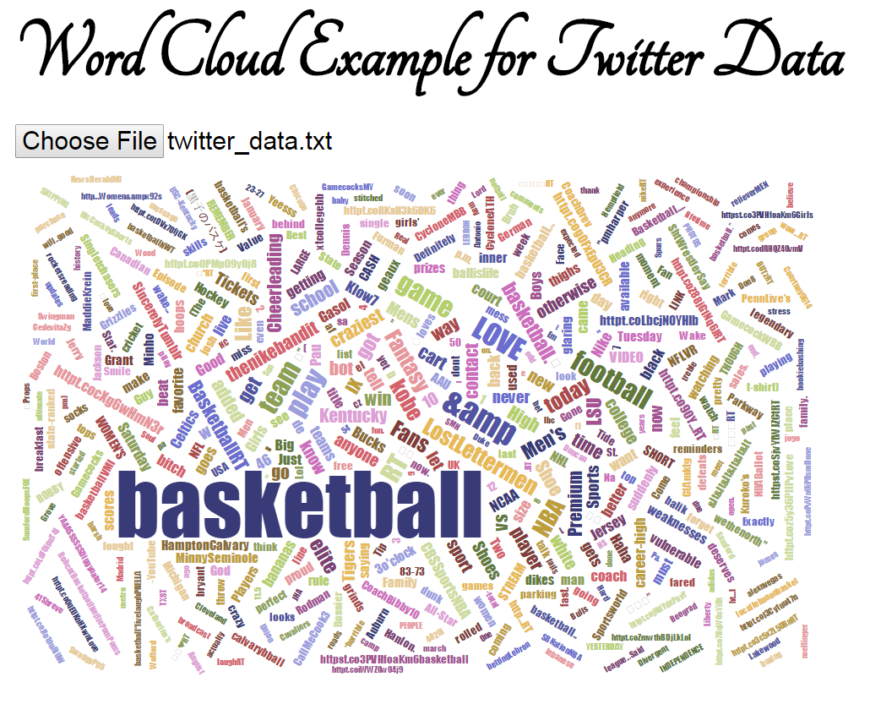

Assignment: In Lab 2, you downloaded tweets data from different locations, e.g., Philadelphia and Boston.

* Show the word clouds of tweets respectively that you crawled from two places.
* Show the word cloud of the most recent two days of the two locations. You can preprocess data in Python to create the files needed for the word cloud program.
* Show any word cloud that might interest you.
* Write up your discoveries.

# Extra Credits (30 Points)

Explore the online resources of D3.js a little. The [tutorial](http://alignedleft.com/tutorials/d3) by Murphy is an excellent starting point, even you have no idea of what is HTML, CSS, JavaScript. Then see whether you can do other D3 visualization with the auto car dataset, twitter data set or the household power consumption data. Some links might be insightful:

* <http://www.gapminder.org/world/> (Wealth of nations)
* <http://www.jasondavies.com/wordcloud>
* <http://mbostock.github.io/d3/talk/20111116/iris-splom.html> (scatterplot)
* <http://neuralengr.com/asifr/journals/> (showing 3 attributes)
* <http://astro.temple.edu/~tuc17157/em_ordering/basic_v2_wave_classes_flip.html> (ordered heatmaps)
* <http://square.github.io/cubism/> (time series)
* <http://bl.ocks.org/wizicer/f662a0b04425fc0f7489> (CS skills in time)
* <http://windhistory.com/map.html#4.00/36.00/-95.00> (spatial data)
* <http://www.trulia.com/vis/tru247/> <http://www.trulia.com/vis/metro-movers/> (spatial temporal data)
* <http://remittances.herokuapp.com/?en> (spatial temporal)
* <http://bost.ocks.org/mike/miserables/>  (graph data)
* <http://www.brightpointinc.com/interactive/political_influence/index.html?source=d3js> (circular plot)
* <http://air.nullschool.net/> (amazing demo)
* <http://bl.ocks.org/fhernand/9a9f93f2a6b0e83a9294> (passes in a game)

# Submission

Submissions are through blackboard. Items to be submitted:

1. The .twb file you created in Tableau.
2. Your write ups for Part 1 and Part 2.
3. Your files for Part 3, which might include the .html, .css, .js files. Please provide a README.txt to explain how to use the files you provided.